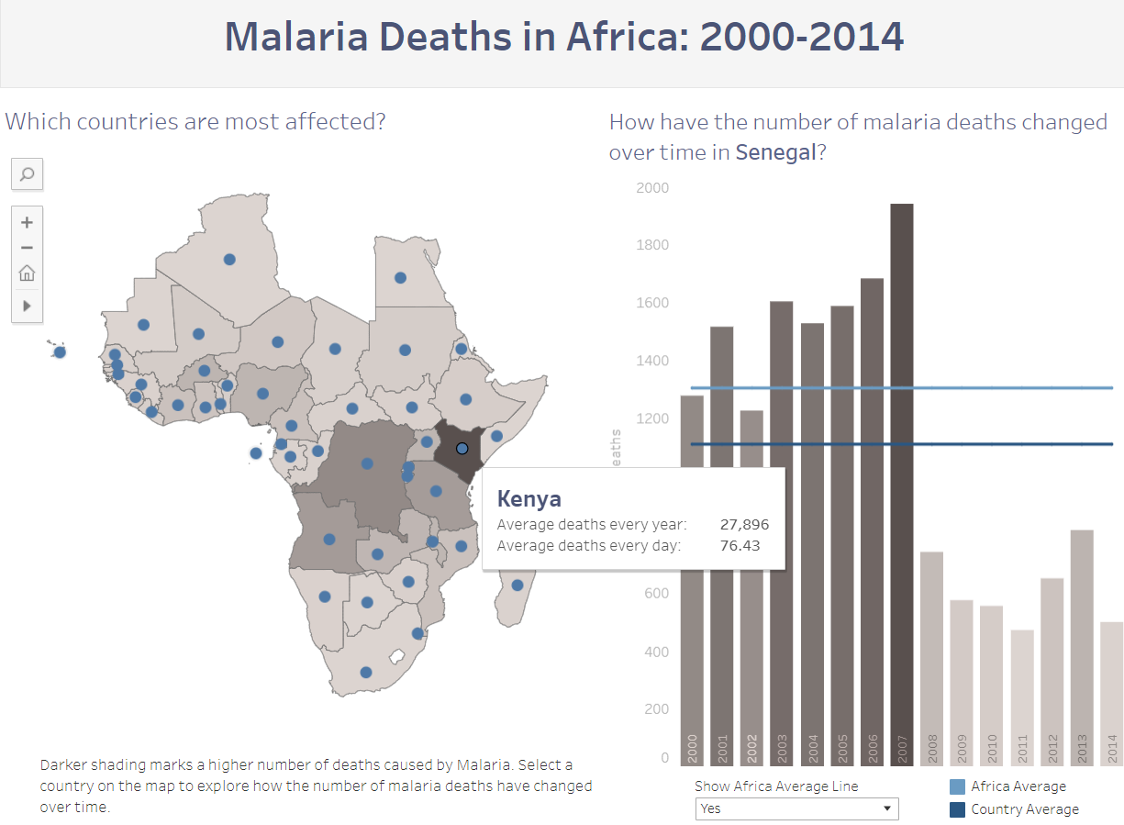

Kenya was the most affected country due to malaria in the period 2000-2014. It had an average of 27896 deaths every year with an average of 76.43 deaths every day. From the dashboard, I saw that Kenya was the darkest shaded and also read below that darker the shade, higher the number of deaths cause by malaria. And when hovered over Kenya, I got the detailed estimate of average deaths every year and every day in the period 2000-2014.

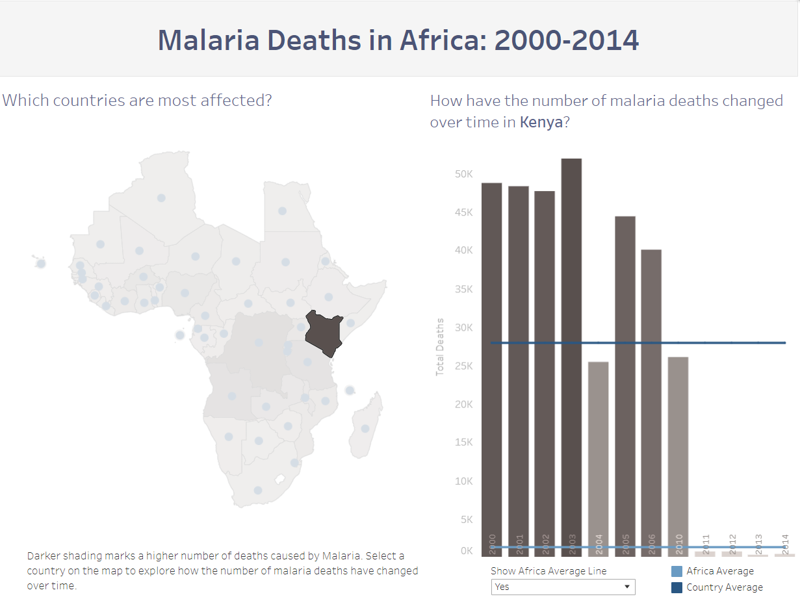

Deaths per year due to Malaria in Kenya drastically decreased to less than 1303 deaths per year (Africa’s Average) after 2010. From the dashboard, I clicked on Kenya on the map, this showed a graph for deaths due to malaria in each year from 2000-2014 and from this graph, we can clearly see that after 2010, the number of deaths fell below the Africa Average of 1303 deaths per year. From 2000 to 2010, they ranged from 25K to 50K deaths per year.

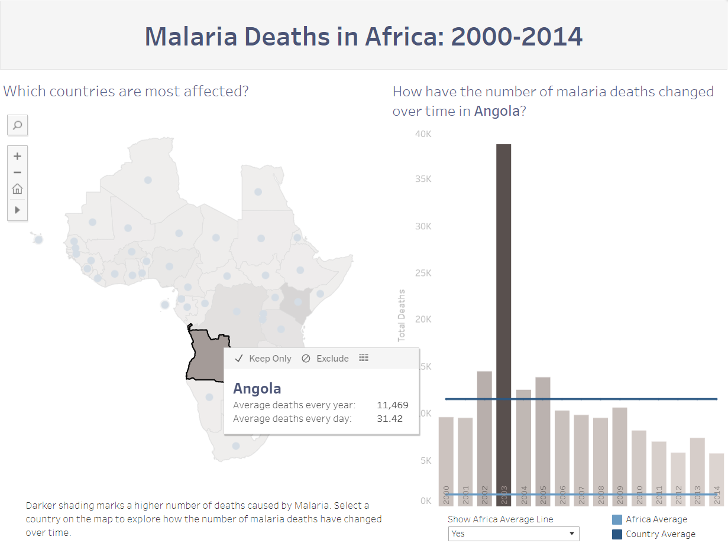

Angola saw a spike in the number of deaths due to Malaria in the year 2003. From the dashboard, I clicked on Angola to explore more about the yearly deaths due to malaria in the period 2000-2014. And it is pretty evident from the graph that Angola had a spike in the number of deaths in the year 2003. We can also infer that, in most of the years, the number of deaths is less that the country average of 11469 except in the years 2002-2005, with having a peak of almost 40K cases in the year 2003.